**Shivam Gautam – AP Assignment 5**

1. [Maximum Depth of Binary Tree](https://leetcode.com/problems/maximum-depth-of-binary-tree/description/)

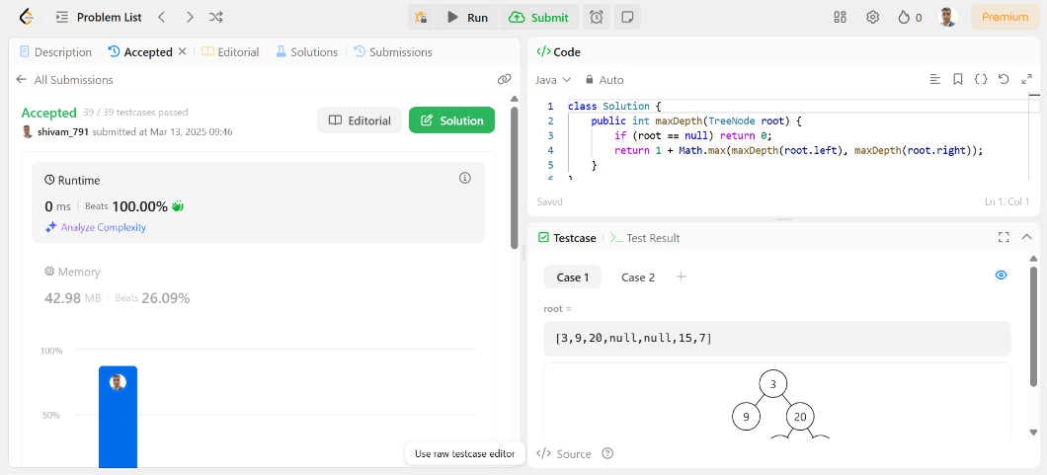

1. [Validate Binary Search Tree](https://leetcode.com/problems/validate-binary-search-tree/description/)

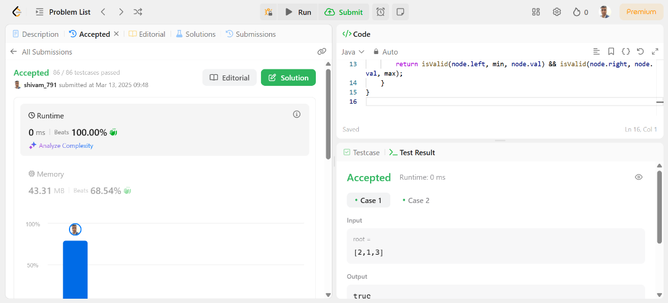

1. [Symmetric Tree](https://leetcode.com/problems/symmetric-tree/description/)

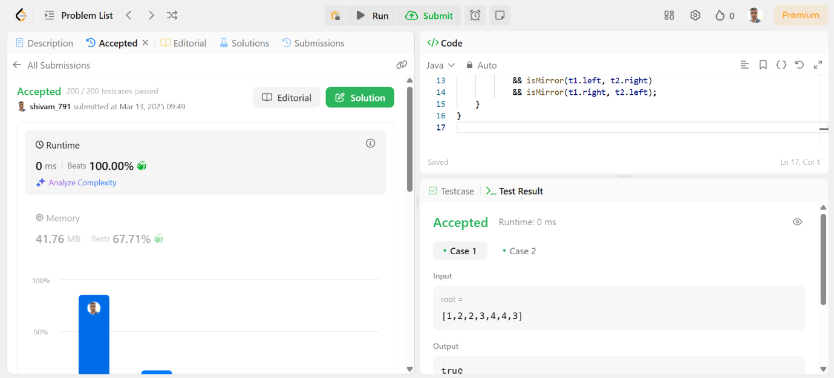

1. [Binary Tree Zigzag Level Order Traversal](https://leetcode.com/problems/binary-tree-zigzag-level-order-traversal/description/)

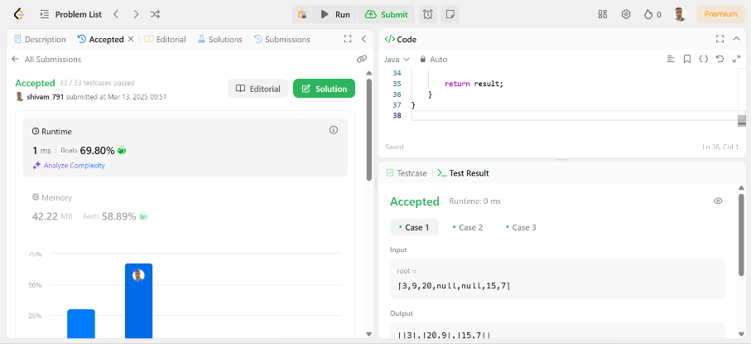

1. [Lowest Common Ancestor of a Binary Tree](https://leetcode.com/problems/lowest-common-ancestor-of-a-binary-tree/description/)

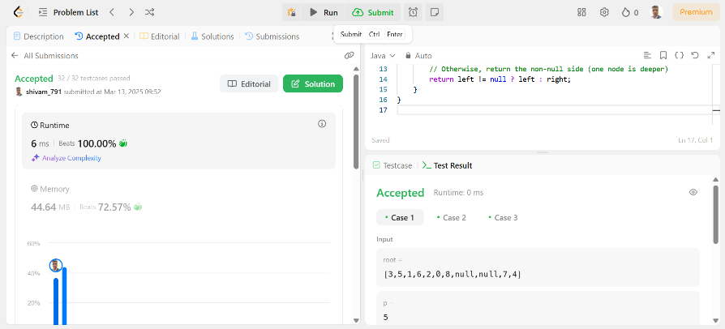

1. [Binary Tree Inorder Traversal](https://leetcode.com/problems/binary-tree-inorder-traversal/description/)

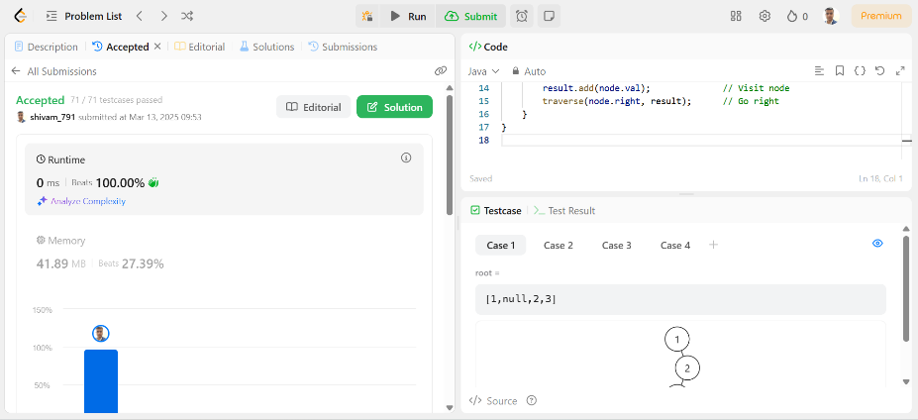

1. [Binary Tree Level Order Traversal](https://leetcode.com/problems/binary-tree-level-order-traversal/description/)

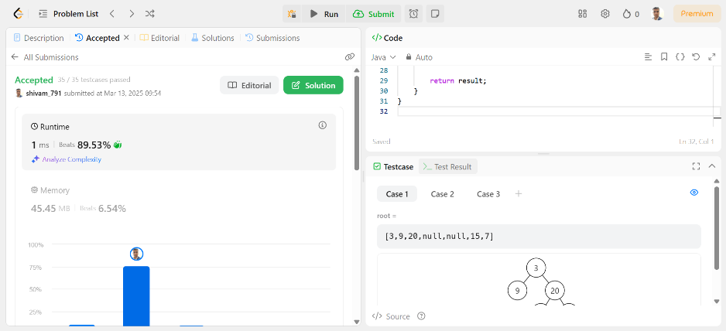

1. [Kth Smallest Element in a BST](https://leetcode.com/problems/kth-smallest-element-in-a-bst/description/)

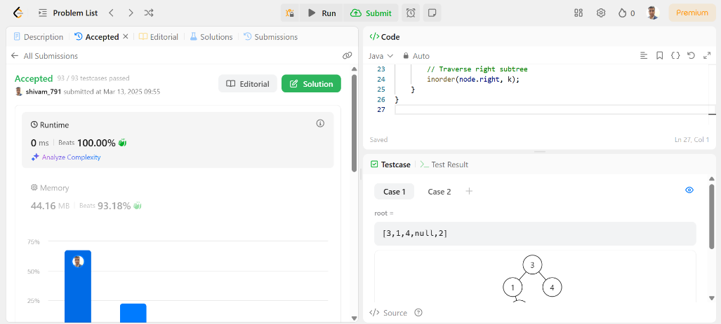

1. [Populating Next Right Pointers in Each Node](https://leetcode.com/problems/populating-next-right-pointers-in-each-node/description/)

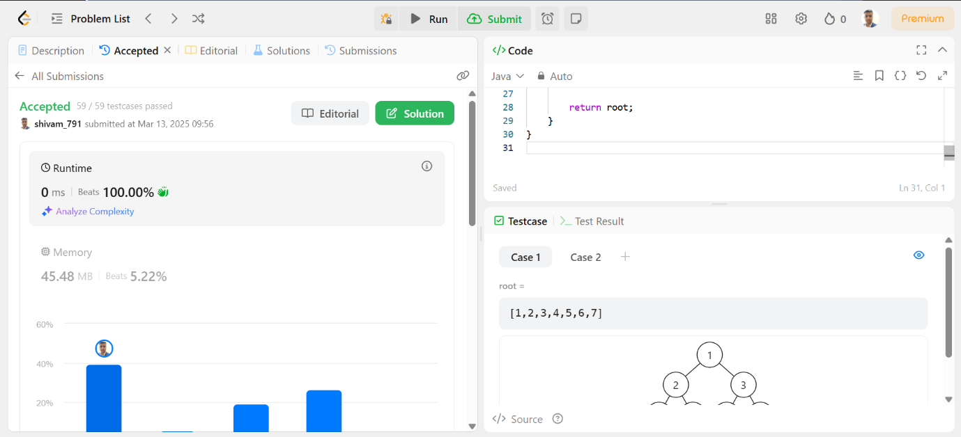

1. [Sum of Left Leaves](https://leetcode.com/problems/sum-of-left-leaves/description/)

